# Putting Together Control Structures

## Question: 1

Which of the following does the clear command do?

A. Clears the screen of any markings left by Tracy

B. Turns Tracy to face right

C. Sends Tracy to position (0,0)

A only

A and B

A and C

A, B, and C

## Question: 2

Which of the following statements is true about control structures?

Placing a for loop inside another for loop will create an infinite loop.

For loops and while loops cannot be used in the same function

If/else statements can be used inside for loops.

User input must always be turned into an integer value in order to be used to control commands

## Question: 3

What would be the output of the following code?

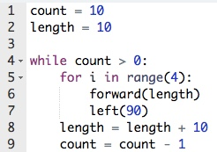

1. 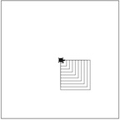
2. 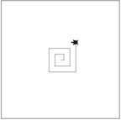
3. 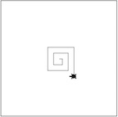
4. 